BANK RECONCILIATION DARESBURY PC
31st MARCH 2024

CASH BOOK | £
Balance b/f | 11318
Receipts | 14277
Payments | 12796
Balance c/f | 12799
BANK BALANCE
Deposit A/C | 200
Deposit A/C | 12599
LESS
Unpresented cheque
 | 12799

Tracey Noble
Clerk to Daresbury Parish Council

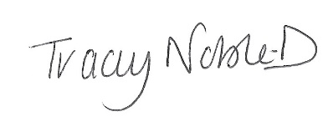

Dated 04th April 2024

